PRACTICAL NO.1

Aim: Write a Program to Implement Breadth First Search using Python.
Theory:
Breadth First Search (BFS) is an uninformed graph traversal algorithm used to explore nodes and edges of a graph systematically. It explores all the nodes at the present depth level before moving on to nodes at the next level.

Working Principle:
- BFS uses a queue data structure (FIFO – First In First Out).
- It begins at the starting (source) node, visits all its neighbours, then moves to the next level of neighbours.
- A visited list (or set) is maintained to avoid revisiting the same node.

Applications of BFS:
- Finding shortest path in unweighted graphs
- Web crawlers
- Social networking sites (friend suggestion)
- GPS navigation systems
- Network broadcasting

Algorithm :
- Create an empty queue and enqueue the starting node.
- Mark the starting node as visited.
- Repeat until the queue is empty: o Dequeue the front node from the queue. o Process the dequeued node.
o Enqueue all unvisited adjacent nodes and mark them as visited.

Program:

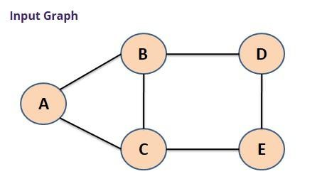
# Input Graph graph = {
'A': ['B', 'C'],
'B': ['A', 'C', 'D'],
'C': ['A', 'B', 'E'],
'D': ['B', 'E'],
'E': ['C', 'D']
}

# To store visited nodes visitedNodes = []

# To store nodes in queue queueNodes = []

# Function for BFS def bfs(visitedNodes, graph, snode):
visitedNodes.append(snode) queueNodes.append(snode) print("\nRESULT :") while queueNodes: s = queueNodes.pop(0) print(s, end=" ")

for neighbour in graph[s]: if neighbour not in visitedNodes: visitedNodes.append(neighbour) queueNodes.append(neighbour)

# Main Code snode = input("Enter Starting Node (A, B, C, D, or E): ").upper()

# Calling bfs function bfs(visitedNodes, graph, snode) Output:
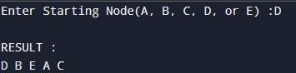
Conclusion: We have successfully executed Program of Breadth First Search using Python.

PRACTICAL NO: 2

Aim: Write a Program to Implement Depth First Search using Python. Theory:
Depth First Search (DFS) is a fundamental graph traversal algorithm used in computer science to explore nodes and edges of a graph. It begins at a starting node (root) and explores as far as possible along each branch before backtracking. DFS explores a node, marks it as visited, then recursively explores its unvisited neighbors. It is like walking through a maze, going as deep as possible before hitting a dead end and turning back.

DFS can be implemented using:
- Recursion (via the function call stack), or
- Explicit stack (for iterative implementation).
Advantages of DFS:
- Requires less memory than BFS (no need to store all neighbors at each level).
- Useful for solving problems where backtracking is needed (like puzzles, topological sorting).

Algorithm: (Recursive DFS)
- Define a function DFS(graph, node, visited):
  - Mark the current node as visited.
  - Print or process the current node.
  - For each neighbor of the current node in graph[node]:
i. If the neighbor has not been visited:
- Recursively call DFS(graph, neighbor, visited)

- Initialize an empty set or list called visited to keep track of visited nodes.
- Call DFS(graph, start_node, visited) Program:

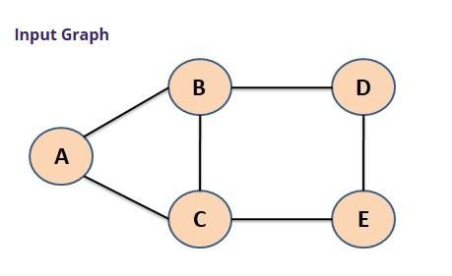
# Input Graph graph = {
'A': ['B', 'C'],
'B': ['A', 'C', 'D'],
'C': ['A', 'B', 'E'],
'D': ['B', 'E'],
'E': ['C', 'D']
}
# List used to store visited nodes visitedNodes = []

# Function for DFS def dfs(visitedNodes, graph, node): if node not in visitedNodes: print(node, end=" ") visitedNodes.append(node) for neighbour in graph[node]:
dfs(visitedNodes, graph, neighbour)

# Driver Code
snode = input("Enter Starting Node (A, B, C, D, or E): ").upper()

# Calling dfs function print("\nRESULT :") print("-" * 20)
dfs(visitedNodes, graph, snode) Output:

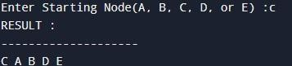

Conclusion: We have Successfully Executed the Program for Depth First Search using Python.

PRACTICAL NO. 3

Aim: Write a Program to Implement Tic-Tac-Toe game using Python.

Theory:
Tic-Tac-Toe is a simple two-player game played on a 3×3 grid. Each player takes turns marking a space in the grid with their symbol—'X' or 'O'. The first player to get three of their symbols in a row (vertically, horizontally, or diagonally) wins the game. If all 9 squares are filled without a winner, the game ends in a draw.
Implementing this game in Python is a common beginner project that strengthens knowledge of: • Lists (for the game board)
- Conditional logic
- Loops
- Functions
- Input/output handling Benefits of Implementation:
- Helps understand game loop logic.
- Enhances problem-solving skills through win/draw detection.
- Introduces the concept of turn-based systems and user input validation.

Algorithm:

Step 1: Initialize the Game Board
- Create a 3×3 board using a list of 9 spaces or a 2D list (3x3 matrix).
- Assign symbols 'X' and 'O' to two players.

Step 2: Define Functions
- display_board(board) — Displays the current state of the board.
- check_winner(board, player) — Checks all rows, columns, and diagonals for a winning pattern for the given player.
- check_draw(board) — Checks if the board is full and there's no winner.
- make_move(board, position, player) — Places the player's symbol on the selected position if valid.
- switch_player(current_player) — Alternates between 'X' and 'O'.

Step 3: Start the Game Loop
- Set the current player as 'X'. Repeat until the game ends:
- Display the board.
- Prompt the current player to enter a position (1 to 9).
- Validate the position: o If invalid or already occupied, show an error and ask again.
o If valid, update the board.
- Check for a winner using check_winner(): o If true, declare the current player as winner and exit loop.
- Check for a draw using check_draw(): o If true, declare the game as a draw and exit loop.
- Switch to the other player.

Step 4: Display Final Result • Print the final state of the board. • Show who won or if it’s a draw.

Step 5: End the Program

Program:

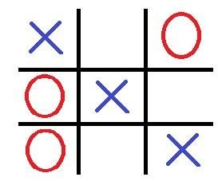
# Tuple to store winning positions win_positions = (
(0, 1, 2), (3, 4, 5), (6, 7, 8),
(0, 3, 6), (1, 4, 7), (2, 5, 8),
(0, 4, 8), (2, 4, 6)
)

def game(player):
# Display current board (mesh) print("\n", " | ".join(mesh[:3]))
print("---+---+---")
print("", " | ".join(mesh[3:6]))
print("---+---+---")
print("", " | ".join(mesh[6:]))

# Loop until player gives a valid input while True: try:
ch = int(input(f"Enter player {player}'s choice (1–9): ")) if str(ch) not in mesh:
raise ValueError
mesh[ch - 1] = player
break except ValueError:
print("Invalid position number. Try again.")

# Return winning positions if player wins, else None for wp in win_positions: if all(mesh[pos] == player for pos in wp):
return wp
return None

# Initialize players and board player1 = "X" player2 = "O" player = player1
mesh = list("123456789")

# Main Game Loop for i in range(9): won = game(player) if won: # Display final board print("\n", " | ".join(mesh[:3])) print("---+---+---") print("", " | ".join(mesh[3:6])) print("---+---+---") print("", " | ".join(mesh[6:]))
print(f"\n*** Player {player} WON! ***") break
player = player1 if player == player2 else player2 else:
# If loop completes without a win print("\nGame ends in a DRAW!") Output:
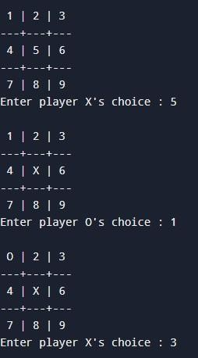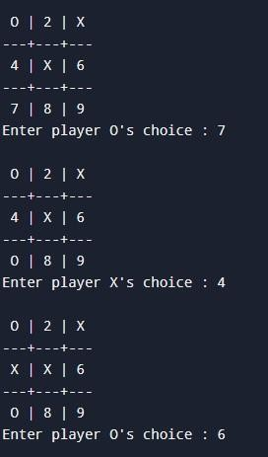

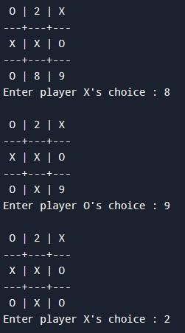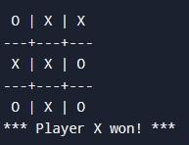
Conclusion: We have Successfully Executed the Program of Tic-Tac-Toe game using Python.

PRACTICAL NO. 4

Aim: Write a Program to Implement 8-Puzzle problem using Python.

Theory:
The 8-puzzle problem is a classic problem in the field of Artificial Intelligence and search algorithms. It consists of a 3x3 grid with 8 numbered tiles (1–8) and one empty space. The goal is to rearrange the tiles from an initial configuration to a goal state by sliding the tiles into the empty space.
The objective is to move the tiles using valid moves (up, down, left, right) until the puzzle reaches the goal configuration. This problem is commonly solved using search algorithms such as:
- Breadth-First Search (BFS)
- A Search Algorithm*
- Depth-First Search (DFS)
- Greedy Best First Search

Applications:
- Understanding heuristic and informed search strategies
- Demonstrates principles of AI planning and pathfinding
- Forms the basis for more complex puzzles (e.g., 15-puzzle, Rubik’s cube solvers)

Algorithm:
Step 1: Define the Initial and Goal States
- Represent the puzzle as a 3×3 matrix or a list of 9 numbers.
- The empty space is denoted by 0.

Step 2: Define a Node Structure Each node contains:
- The current puzzle state.
- The cost to reach this state g(n).
- The heuristic value h(n) (e.g., Manhattan Distance).
- The total cost f(n) = g(n) + h(n).
- The parent node (to trace the path later).

Step 3: Define the Heuristic Function
- Manhattan Distance:
text
CopyEdit
For each tile (except 0), compute:
abs(current_row - goal_row) + abs(current_col - goal_col)
- Sum for all tiles gives h(n).

Step 4: Initialize the Open and Closed Lists
- open_list: Priority queue containing nodes to be explored (sorted by f(n)).
- closed_set: Set of already visited states.

Step 5: Begin A Search Loop*
1. While open_list is not empty:
- Remove the node with the lowest f(n) from open_list.
- If the current state is the goal state:
▪ Reconstruct and return the path from start to goal.
- Add the current state to closed_set.
- Generate all valid moves (up, down, left, right):
  - Swap the blank tile with the target tile.
  - If the new state is not in closed_set:
  - Calculate g(n) (cost so far).
  - Calculate h(n) using heuristic. ▪ Compute f(n) = g(n) + h(n) ▪ Add the new node to open_list.

Step 6: If Goal Not Found
• If open_list becomes empty and goal not reached, return failure.

Program:

from collections import deque def bfs(start_state):
target = [1, 2, 3, 4, 5, 6, 7, 8, 0] dq = deque([start_state]) visited = {tuple(start_state): None} while dq:
state = dq.popleft() if state == target: # Reconstruct the path path = [] while state:
path.append(state) state = visited[tuple(state)]
return path[::-1] # Reverse the path for correct order zero = state.index(0) row, col = divmod(zero, 3)
# Possible moves: up (-3), down (+3), left (-1), right (+1) for move in (-3, 3, -1, 1): new_pos = zero + move if 0 <= new_pos < 9:
new_row, new_col = divmod(new_pos, 3)
# Ensure movement is valid (no wrapping across rows) if abs(row - new_row) + abs(col - new_col) == 1:
neighbor = state[:] neighbor[zero], neighbor[new_pos] = neighbor[new_pos], neighbor[zero] if tuple(neighbor) not in visited: visited[tuple(neighbor)] = state dq.append(neighbor) return None # No solution found
def printSolution(path): for state in path: for i in range(0, 9, 3):
print(' '.join(map(str, state[i:i+3]))) print("-----")
# Example Usage
startState = [1, 3, 0, 6, 8, 4, 7, 5, 2] solution = bfs(startState) if solution:
printSolution(solution) print(f"Solved in {len(solution) - 1} moves.") else:
print("No solution found.") Output:

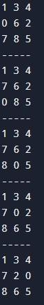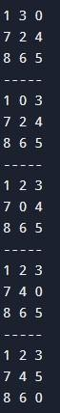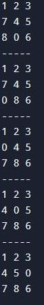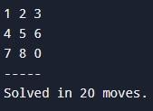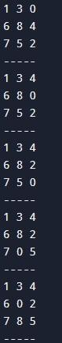

Conclusion: We have Successfully Executed the Program for 8-Puzzle problem using Python.
PRACTICAL NO: 5 Aim: Write a Program to Implement Water-Jug problem using Python.
Theory:
The Water-Jug Problem is a classic problem in Artificial Intelligence and problem-solving. It involves using two jugs with different capacities to measure out a specific amount of water using only the jugs and unlimited water supply. For example:
- Jug A has capacity 4 liters
- Jug B has capacity 3 liters
- Goal: Measure 2 liters of water. Approach Used:
To solve the problem, we can use Breadth-First Search (BFS) or Depth-First Search (DFS) to explore all possible states until the goal is found.
The idea is to model each state as a node in a graph and generate its successors using valid operations. Algorithm:
- Start
Initialize the jug capacities:
Let jug1_capacity, jug2_capacity, and target be the inputs.
- Define the State
Represent the state as a pair (x, y) where:
  - x = current amount in Jug 1 o y = current amount in Jug 2
- Initialize o Create a queue for BFS and add the initial state (0, 0) o Create a visited set to track visited states
  - Create a dictionary to store the parent of each state (for tracing the solution path)
- BFS Loop
Repeat until the queue is empty: o Dequeue the front
state (x, y)
  - If x == target or y == target: → Goal is reached, break o For each of the following valid operations, generate a new state:
    - Fill Jug 1: (jug1_capacity, y) ▪ Fill Jug 2: (x, jug2_capacity)
    - Empty Jug 1: (0, y) ▪ Empty Jug 2: (x, 0)
    - Pour Jug 1 → Jug 2
    - Pour Jug 2 → Jug 1 o If a new state has not been visited:
    - Add it to the queue and visited set
    - Record its parent for path tracing
- Trace Path (Optional) o Use the parent dictionary to backtrack from the goal to the initial state and get the sequence of steps.
- End

Program:
# Jug capacities and goal
jug1, jug2, goal = 4, 3, 2

# Initialize a 2D list for visited states
# The list will have dimensions (jug1+1) x (jug2+1) to cover all possible states visited = [[False for _ in range(jug2 + 1)] for _ in range(jug1 + 1)]

def waterJug(vol1, vol2):
# Check if we reached the goal state if (vol1 == goal and vol2 == 0) or (vol2 == goal and vol1 == 0):
print(vol1, "\t", vol2) print("Solution Found ✅")
return True

# If this state has been visited, return False if visited[vol1][vol2]:
return False

# Mark this state as visited
visited[vol1][vol2] = True

# Print the current state
print(vol1, "\t", vol2)

# Try all possible moves:
return (
waterJug(0, vol2) or # Empty jug1 waterJug(vol1, 0) or # Empty jug2 waterJug(jug1, vol2) or # Fill jug1 waterJug(vol1, jug2) or # Fill jug2 # Pour water from jug2 to jug1
waterJug(vol1 + min(vol2, (jug1 - vol1)), vol2 - min(vol2, (jug1 - vol1))) or
# Pour water from jug1 to jug2
waterJug(vol1 - min(vol1, (jug2 - vol2)), vol2 + min(vol1, (jug2 - vol2)))
)

# Driver Code print("Steps:") print("Jug1\tJug2")
print("-----\t-----")

waterJug(0, 0) Output:

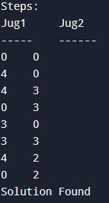

Conclusion: We have Successfully Executed the program to Implement Water-Jug problem using Python.

PRACTICAL NO: 6

Aim: Write a Program to Implement Travelling Salesman Problem using Python.

Theory:

The Travelling Salesman Problem (TSP) is one of the most famous problems in computer science and operations research. It focuses on optimization and is classified as an NP-Hard problem.
A salesman needs to visit a set of cities exactly once and return to the starting city. The goal is to find the shortest possible route that visits each city once and returns to the original city.

Problem Definition:
Given:
- A set of cities.
- The distance (or cost) between each pair of cities.
Objective:
- Find the shortest path that visits every city exactly once and returns to the starting city.

Applications:
- Logistics and delivery routing.
- Microchip manufacturing.
- DNA sequencing.
- Robotics path planning.

Limitations:
- Not suitable for very large number of cities (e.g., >20) due to exponential time.
- Approximation or heuristic methods are preferred for large-scale TSP.

Algorithm:

Input:
- A cost matrix cost[n][n] representing distances between n cities.
Output:
- The minimum cost of the tour that visits every city exactly once and returns to the starting city.

Steps:
- Initialize Constants: o Let n be the number of cities.
o Let dp[2^n][n] be a 2D array to store minimum costs. o dp[mask][i] means minimum cost to reach city i having visited cities represented by mask.
- Base Case Initialization: o Set all values of dp to infinity (inf). o Set dp[1 << i][i] = cost[0][i] for all cities i ≠ 0.
- Dynamic Programming Recurrence: o For all mask from 0 to 2^n - 1:
    - For all cities u (current city) in mask:
    - For all cities v not in mask:
    - Update: dp[mask | (1 << v)][v] = min(dp[mask | (1 << v)][v], dp[mask][u] + cost[u][v])
- Compute Final Answer: o After filling the table, the answer is:
css
CopyEdit min(dp[(1<<n)-1][i] + cost[i][0]) for all i from 1 to n-1 (This completes the tour by returning to the starting city 0)
- Return the Minimum Cost.

Program:

from collections import deque

def tsp_bfs(graph):
n = len(graph) # Number of cities startCity = 0 # Starting city min_cost = float('inf') # Initialize minimum cost as infinity opt_path = [] # To store the optimal path

# Queue for BFS: Each element is (cur_path, cur_cost) dq = deque([([startCity], 0)])

print("Path Traversal:")

while dq:
cur_path, cur_cost = dq.popleft() cur_city = cur_path[-1]

# Print the current path and cost
print(f"Current Path: {cur_path}, Current Cost: {cur_cost}")

# If all cities are visited if len(cur_path) == n:
# Return to startCity to complete the cycle total_cost = cur_cost + graph[cur_city][startCity] if total_cost < min_cost: min_cost = total_cost opt_path = cur_path + [startCity] continue

# Explore all neighboring cities (in BFS manner) for next_city in range(n):
if next_city not in cur_path: # Visit only unvisited cities new_path = cur_path + [next_city] new_cost = cur_cost + graph[cur_city][next_city] dq.append((new_path, new_cost))

return min_cost, opt_path

# Example graph as a 2D adjacency matrix graph = [
[0, 10, 15, 20],
[10, 0, 35, 25],
[15, 35, 0, 30],
[20, 25, 30, 0]
]

# Solve TSP using BFS
min_cost, opt_path = tsp_bfs(graph)

print("\nOptimal Solution:") print(f"Minimum cost: {min_cost}")
print(f"Optimal path: {opt_path}")

Output:
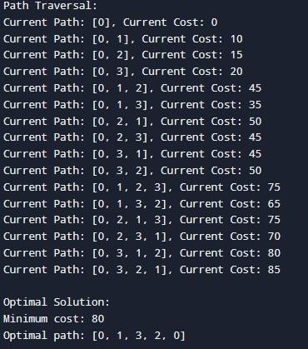

Conclusion: We have Successfully Executed the program to Implement Travelling Salesman Problem using Python.

PRACTICAL NO: 7

Aim: Write a Program to Implement Tower of Hanoi using Python.

Theory:

The Tower of Hanoi is a classic recursive problem in computer science and mathematics. It involves moving a stack of disks from one rod (source) to another rod (destination) using an auxiliary rod, following specific rules.
Need to Convert Infix to Postfix
Infix expressions are natural for humans to read but difficult for computers to evaluate due to parentheses and operator precedence.
Postfix expressions:
- Do not need parentheses
- Are easier and faster to evaluate using a stack
- Obey strict left-to-right evaluation

Rules of the Tower of Hanoi:
- Only one disk can be moved at a time.
- A move consists of taking the top disk from one rod and placing it on top of another rod.
- No disk may be placed on top of a smaller disk.

Applications:
- Understanding recursion and divide-and-conquer algorithms.
- Used in algorithm design, mathematical puzzles, and computer science education.

Algorithm:

Input:
- n: Number of disks
- source: The peg from which to move the disks (e.g., 'A')
- auxiliary: The peg to use for temporary storage (e.g., 'B') • destination: The peg to move the disks to (e.g., 'C')

Steps:
- Start
- If n == 1 (base case): o Move disk from source to destination
- Else: o Recursively move n-1 disks from source to auxiliary using destination as temporary
  - Move the remaining 1 disk from source to destination
  - Recursively move n-1 disks from auxiliary to destination using source as temporary 4. End

Program:
def tower_of_hanoi(num, source, aux, target):
"""
Solves the Tower of Hanoi problem using recursion.

Parameters:
num (int): Number of disks.
source (str): The name of the source tower. aux (str): The name of the auxiliary tower. target (str): The name of the target tower.
""" if num == 1:
print(f"Move disk 1 from {source} to {target}")
return

# Move num-1 disks from source to auxiliary tower_of_hanoi(num - 1, source, target, aux)

# Move the nth disk from source to target
print(f"Move disk {num} from {source} to {target}")

# Move the num-1 disks from auxiliary to target tower_of_hanoi(num - 1, aux, source, target)

# Example usage num_disks = 3 tower_of_hanoi(num_disks, "A", "B", "C")Output:

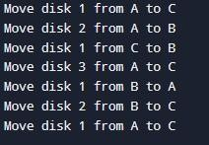

Conclusion: We have Successfully Executed Program to Implement Tower of Hanoi using Python.

PRACTICAL NO: 8

Aim: Write a Program to Implement Monkey Banana Problem using Python. Theory:

The Monkey and Banana problem is a classic example of a problem-solving scenario in Artificial Intelligence (AI), especially in the domain of planning and reasoning. It was originally introduced to study goal-based agents and AI planning in a structured environment. In this problem, a monkey is placed in a room where bananas are hanging from the ceiling, and the monkey must find a sequence of actions to get the bananas using a box placed in the room. The challenge lies in finding the correct sequence of actions.

Problem Description
- The monkey is in a room.
- Bananas are hanging from the ceiling — the monkey cannot reach them from the ground.
- A box is present in the room — the monkey can climb on it to reach the bananas.
- The monkey can perform several actions: o Walk to the box.
o Push the box to a location under the bananas. o Climb onto the box. o Grab the bananas.

Algorithm:
- Define the State Structure: o A state can be represented as a tuple:

(Monkey_Location, Box_Location, Monkey_Position, Has_Banana)
Example: ("door", "middle", "floor", False)
- Initialize Initial State:
  - Monkey_Location = "door" o Box_Location = "middle" o Monkey_Position = "floor" o Has_Banana = False
- Define Goal State: o The monkey has the banana:
Has_Banana = True
- Define Possible Actions with Preconditions and Effects: o Move(location): Monkey moves to a new location. o Push(box_location, new_location): Monkey pushes the box to new location. o ClimbUp(): Monkey climbs onto the box. o ClimbDown(): Monkey climbs down from the box.
  - Grasp(): Monkey grabs the banana (only if on the box and under banana).
- Create a Queue or Stack for Search: o Use BFS or DFS. o Store pairs of (state, action_path).
- While the queue is not empty:
  - Remove the front node from the queue.
  - If the current state satisfies the goal condition:
    - Return the list of actions to reach this state. o Otherwise:
    - For each valid action from this state:
    - Generate a new state.
    - If the state is not visited, add it to the queue with the updated path.
- If queue is empty and goal not reached: o Return “No solution found.”

Program:
from collections import deque

def monkey_banana_problem():
# Initial state (Monkey's Location, Chair Position, Monkey's Position on Chair, Monkey's Status) initial_state = ('Far-Chair', 'Chair-Not-Under-Banana', 'Off-Chair', 'Empty') print(f"\nInitial state is {initial_state}")

# Goal state when the monkey has the banana
goal_state = ('Near-Chair', 'Chair-Under-Banana', 'On-Chair', 'Holding')

# Possible actions and their effects actions = {
"Move to Chair": lambda state: (
'Near-Chair', state[1], state[2], state[3]
) if state[0] != 'Near-Chair' else None,

"Push Chair under Banana": lambda state: (
'Near-Chair', 'Chair-Under-Banana', state[2], state[3]
) if state[0] == 'Near-Chair' and state[1] != 'Chair-Under-Banana' else None,

"Climb Chair": lambda state: (
'Near-Chair', 'Chair-Under-Banana', 'On-Chair', state[3]
) if state[0] == 'Near-Chair' and state[1] == 'Chair-Under-Banana' and state[2] != 'On-Chair' else None,

"Grasp Banana": lambda state: (
'Near-Chair', 'Chair-Under-Banana', 'On-Chair', 'Holding' ) if state[0] == 'Near-Chair' and state[1] == 'Chair-Under-Banana' and state[2] == 'On-Chair' and state[3] != 'Holding' else None
}

# BFS to explore states
dq = deque([(initial_state, [])]) # Each element = (current_state, actions_taken) visited = set()

while dq:
current_state, actions_taken = dq.popleft()

# Check if we've reached the goal if current_state == goal_state: print("\n✅ Solution Found!") print("\nActions to achieve goal:\n") for action in actions_taken:
print(action)
print(f"\nFinal State: {current_state}") return

# Mark the current state as visited if current_state in visited: continue
visited.add(current_state)

# Try all possible actions for action_name, action_func in actions.items():
next_state = action_func(current_state) if next_state and next_state not in visited:
dq.append((next_state, actions_taken + [f"Action: {action_name}, Resulting State: {next_state}"]))

print("❌ No solution found.")

# Run the program monkey_banana_problem() Output:
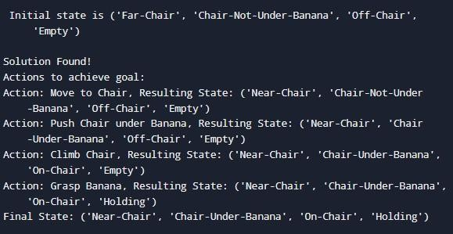
Conclusion: We have Successfully Executed the Program to Implement Monkey Banana Problem using Python

PRACTICAL NO: 9

Aim: Write a Program to Implement Alpha-Beta Pruning using Python.

Theory:
Alpha-Beta Pruning is an optimization technique for the Minimax algorithm, widely used in
Artificial Intelligence (AI), especially in two-player turn-based games like Tic-Tac-Toe, Chess, or Checkers. It reduces the number of nodes evaluated in the search tree, making decision-making more efficient without affecting the final result.

Purpose of Alpha-Beta Pruning
- To optimize the Minimax algorithm.
- To avoid unnecessary computations by pruning branches that do not influence the final decision.
- To improve search efficiency, especially in games with large decision trees.

Working Principle
Alpha-Beta pruning maintains two values during the search:
- Alpha (α): The best value that the maximizer currently can guarantee.
- Beta (β): The best value that the minimizer currently can guarantee. Key rule:
- If Beta ≤ Alpha, further exploration of that node is pruned (cut off), because it cannot affect the final decision.

Algorithm:
Step 1: Start
Step 2: Define the Alpha-Beta function with the following parameters:
- node: current node in the tree
- depth: current depth of the node
- isMaximizingPlayer: Boolean, true for maximizer's turn, false for minimizer's
- alpha: best value that the maximizer can guarantee
- beta: best value that the minimizer can guarantee

Step 3: Check if terminal condition is met
(Depth is 0 or node is a terminal node)
- Return the heuristic value of the node

Step 4: If isMaximizingPlayer is True:
- Initialize maxEval = -∞
- For each child of the node: o Call the Alpha-Beta function recursively with:
  - depth - 1, isMaximizingPlayer = False, updated alpha, beta o Update maxEval = max(maxEval, eval) o Update alpha = max(alpha, eval) o If beta ≤ alpha: Break (prune branch)
- Return maxEval

Step 5: Else (Minimizing Player’s Turn):
- Initialize minEval = +∞
- For each child of the node: o Call the Alpha-Beta function recursively with:
  - depth - 1, isMaximizingPlayer = True, updated alpha, beta o Update minEval = min(minEval, eval) o Update beta = min(beta, eval) o If beta ≤ alpha: Break (prune branch)
- Return minEval

Step 6: End

Program:
"""
Alpha–Beta Pruning:
-------------------
This algorithm is an optimization of the Minimax algorithm.
It eliminates branches in the game tree that don't need to be explored because they cannot possibly affect the final decision.

Parameters:
-----------
depth (int): Current depth in the game tree.
node_index (int): Index of the current node in the values array.
maximizing_player (bool): True if the current player is maximizing, False otherwise.
values (list): List of leaf node values. alpha (float): Best value for the maximizing player. beta (float): Best value for the minimizing player.

Returns:
--------
int: The optimal value for the current player.
"""

import math

def alpha_beta_pruning(depth, node_index, maximizing_player, values, alpha, beta):
# Base case: If we've reached the leaf node if depth == 0 or node_index >= len(values):
return values[node_index]

# If it's the maximizing player's turn if maximizing_player: max_eval = -math.inf
for i in range(2): # Each node has two children eval = alpha_beta_pruning(depth - 1, node_index * 2 + i, False, values, alpha, beta) max_eval = max(max_eval, eval)
alpha = max(alpha, eval)

# Beta cut-off if beta <= alpha: break
return max_eval

# If it's the minimizing player's turn else:
min_eval = math.inf
for i in range(2): # Each node has two children eval = alpha_beta_pruning(depth - 1, node_index * 2 + i, True, values, alpha, beta) min_eval = min(min_eval, eval)
beta = min(beta, eval)

# Alpha cut-off if beta <= alpha: break
return min_eval

# Example usage if __name__ == "__main__":
# Leaf node values for a complete binary tree
values = [3, 5, 6, 9, 1, 2, 0, -1]
depth = 3 # Height of the tree

optimal_value = alpha_beta_pruning(depth, 0, True, values, -math.inf, math.inf) print(f"The optimal value is: {optimal_value}")Output:

Conclusion: We have Successfully Executed a Program to Implement Alpha-Beta Pruning using Python.

PRACTICAL NO: 10

Aim: Write a Program to Implement 8-Queens Problem using Python.

Theory:
The 8-Queens Problem is a classic example of the backtracking algorithm in Artificial Intelligence and Computer Science. The problem is to place eight queens on an 8×8 chessboard such that no two queens threaten each other. This means:
- No two queens can be in the same row,
- No two queens can be in the same column, • No two queens can be on the same diagonal.

Problem Solving Approach
To solve this problem, we use recursive backtracking:
- Start from the first row and try placing a queen in each column one by one.
- Before placing a queen, check if the position is safe (i.e., it is not under attack from any previously placed queens).
- If a safe position is found, place the queen and move to the next row.
- If placing the queen leads to a solution, continue. If not, backtrack and try another column in the previous row.
- Continue this process until all 8 queens are placed successfully or all possibilities are exhausted.
Applications
- This problem is a typical use-case of constraint satisfaction problems.
- It demonstrates backtracking, a foundational technique in AI.
- Solving N-Queens helps understand optimization, search techniques, and state space exploration.

Algorithm:
- Start
Create an 8×8 chessboard initialized with empty values (0 or .).
- Define a function is_safe(board, row, col) o Check if there is a queen in the same column in previous rows. o Check the upper-left diagonal for a queen. o Check the upper-right diagonal for a queen.
o Return True if it is safe, otherwise False.
- Define a recursive function solve(board, row) o If row == 8, all queens are placed → Print the board and return True.
o For each column col from 0 to 7:
▪ If is_safe(board, row, col):
▪ Place a queen at board[row][col].
▪ Recursively call solve(board, row + 1). ▪ If recursive call returns True, return True.
▪ Else, Backtrack → Remove the queen from board[row][col].
- In the main function: o Initialize the board with 0 or .. o Call solve(board, 0) to begin placing from the first row.
o If no solution is found, print "No solution exists".
- End
- End

Program:
def printSolution(board):
"""Print the chessboard configuration.""" for row in board:
print(" ".join("Q" if col else "." for col
in row))
print("\n")

def isSafe(board, row, col, n): """Check if placing a queen at board[row][col] is safe."""

# Check the same column for i in range(row): if board[i][col]: return False

# Check upper-left diagonal i, j = row, col while i >= 0 and j >= 0: if board[i][j]:
return False i -= 1 j -= 1

# Check upper-right diagonal i, j = row, col while i >= 0 and j < n: if board[i][j]: return False i -= 1
j += 1

return True

def solveNQueens(board, row, n): """Use backtracking to solve the NQueens problem.""" if row == n: printSolution(board)
return True

result = False for col in range(n): if isSafe(board, row, col, n): # Place the queen
board[row][col] = 1

# Recur to place the rest of the queens
result = solveNQueens(board, row + 1, n) or result

# Backtrack if placing queen here doesn't lead to a solution
board[row][col] = 0

return result

def nQueens(n):
"""Driver function to solve the N-Queens problem.""" board = [[0] * n for _ in range(n)]

if not solveNQueens(board, 0, n): print("No solution exists.") else:
print("Solutions printed above.")

# Solve the 8-Queens problem
nQueens(8)

Output:
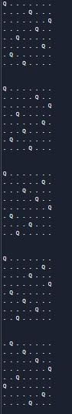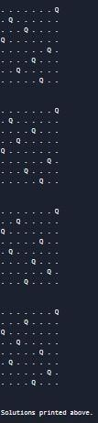
Conclusion: We have Successfully executed a Program to Implement 8-Queens Problem using Python.

